**AWS NACL+SECURITY GROUPS PROJECT WITH VPC AND EC2**

Procedure or steps to follow:

1.create vpc along with subnets route table internet gateway and NACL’S

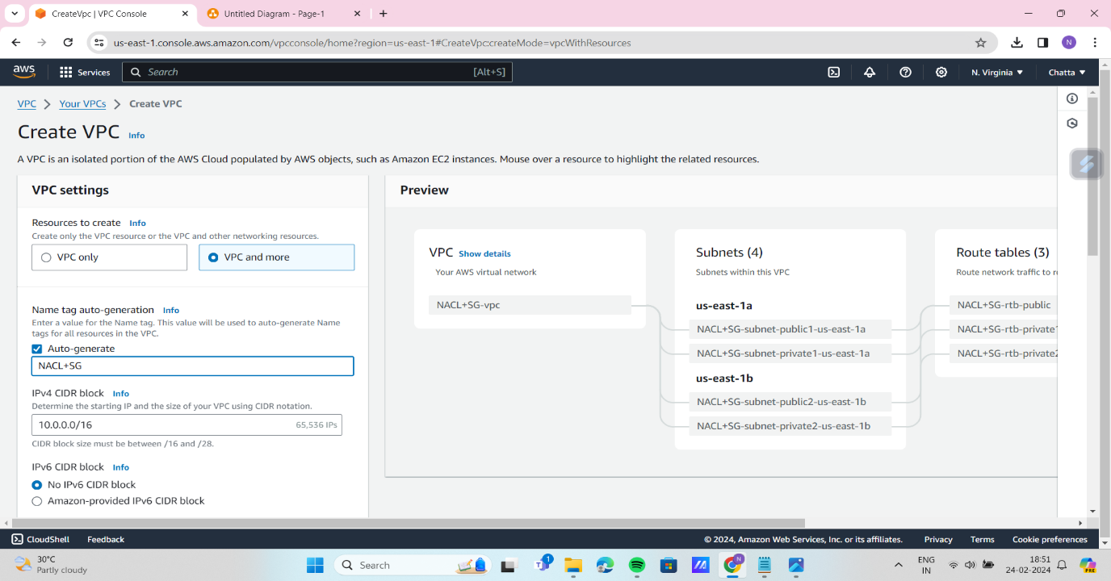

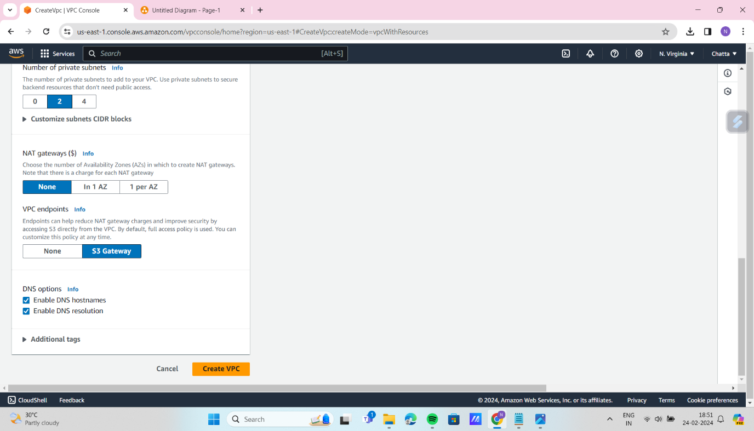

1.1 click on create vpc you will get all no need to create specifically(subnets,routetable,internet gateway,nacl)

2.Create ec2 instance with the vpc what you created just now .follow this

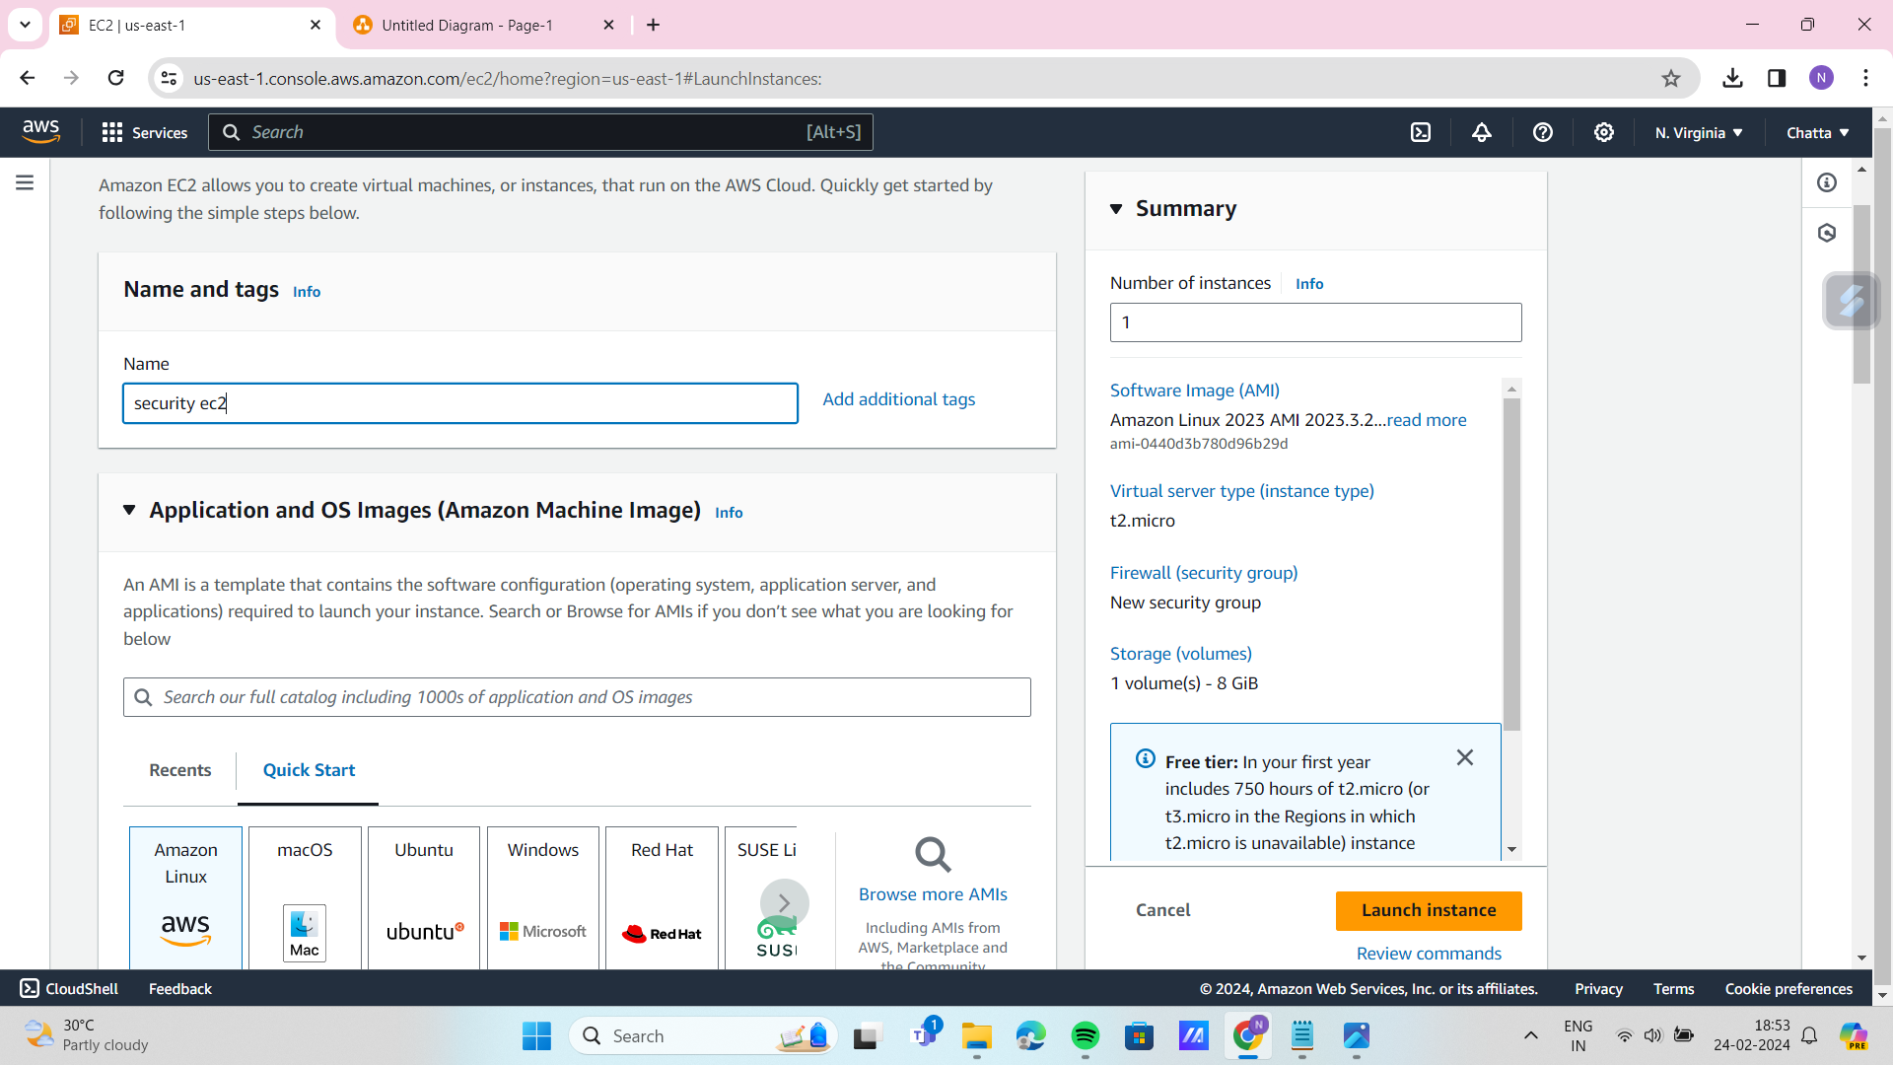

2.1 select key pair.

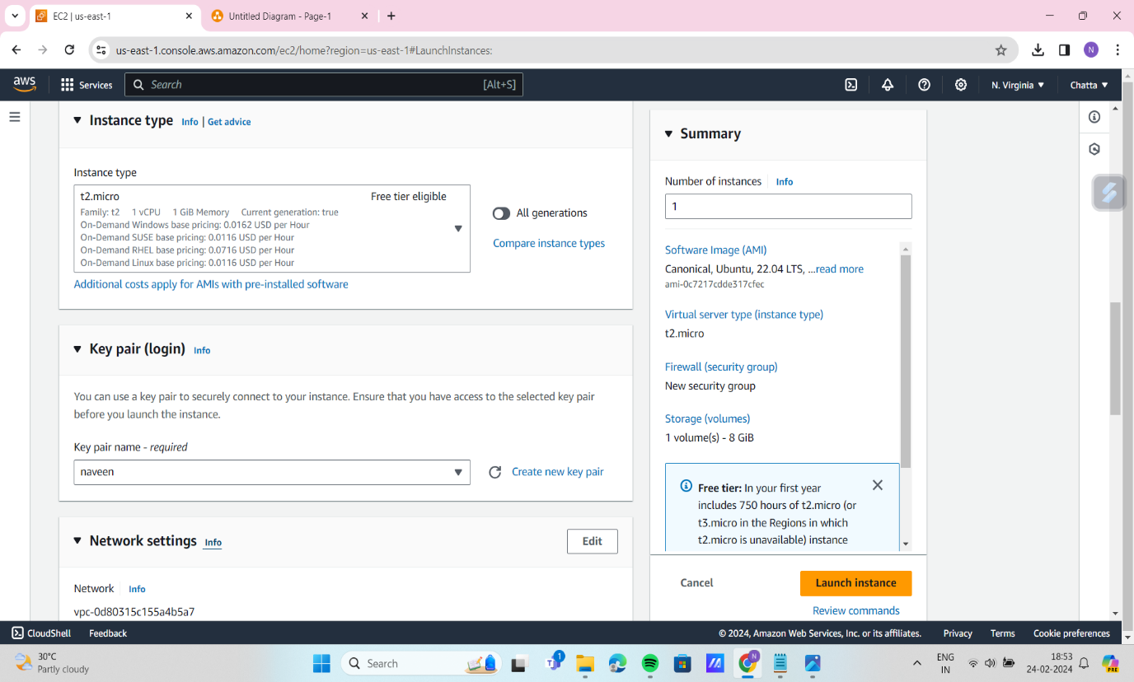

2.2 Select operating system as obuntu.

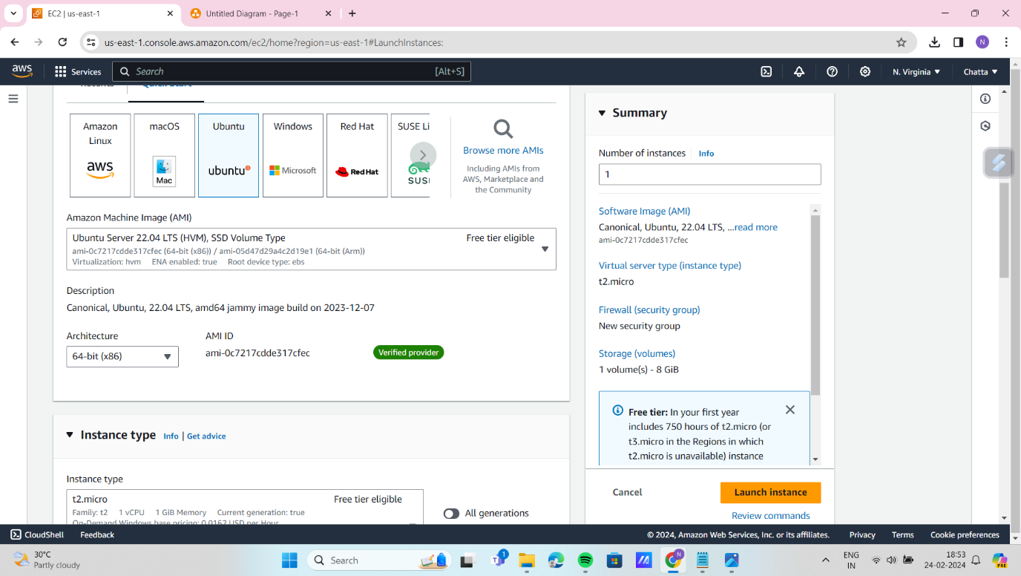

2.3 click on edit network settings select your vpc not default one and select one public subnet enable the Auto-assign public ip. And click on create ec2.

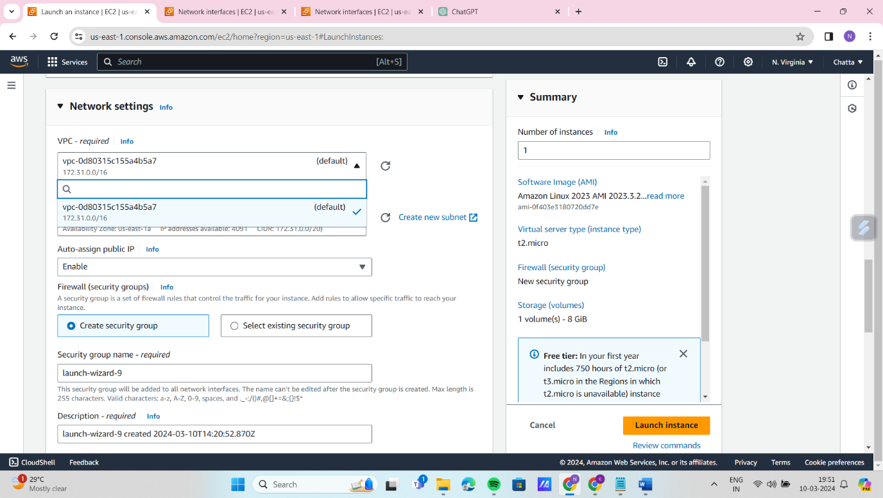

2.4 Click on ec2 instance and connect to ec2.you will get terminal like this

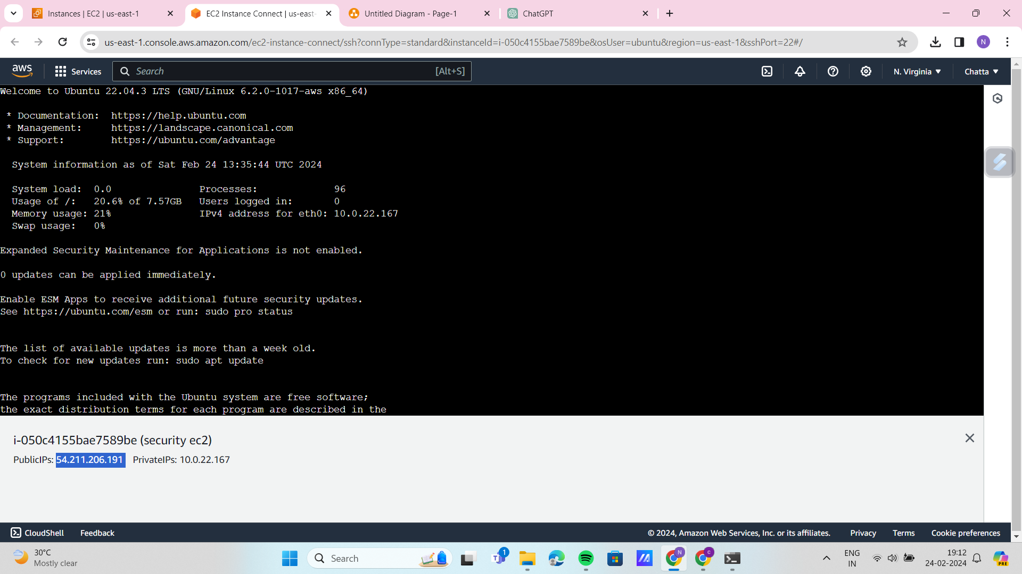

2.5 Give this following command on terminal to update the packages and to run the python application on port 8000.

- sudo apt update

- python3 -m http.server of ec2

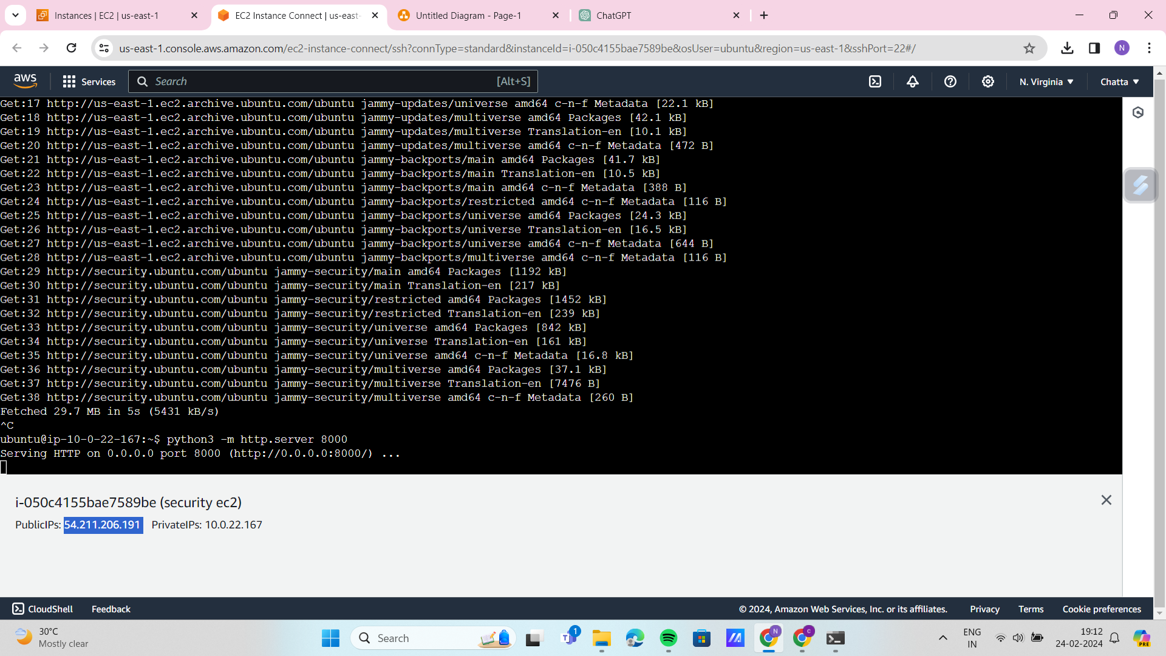

2.6 Copy the public IP that is present below the terminal and browse it on new tab it will not reach to your application,you have to edit the inbound rules in security groups of ec2.

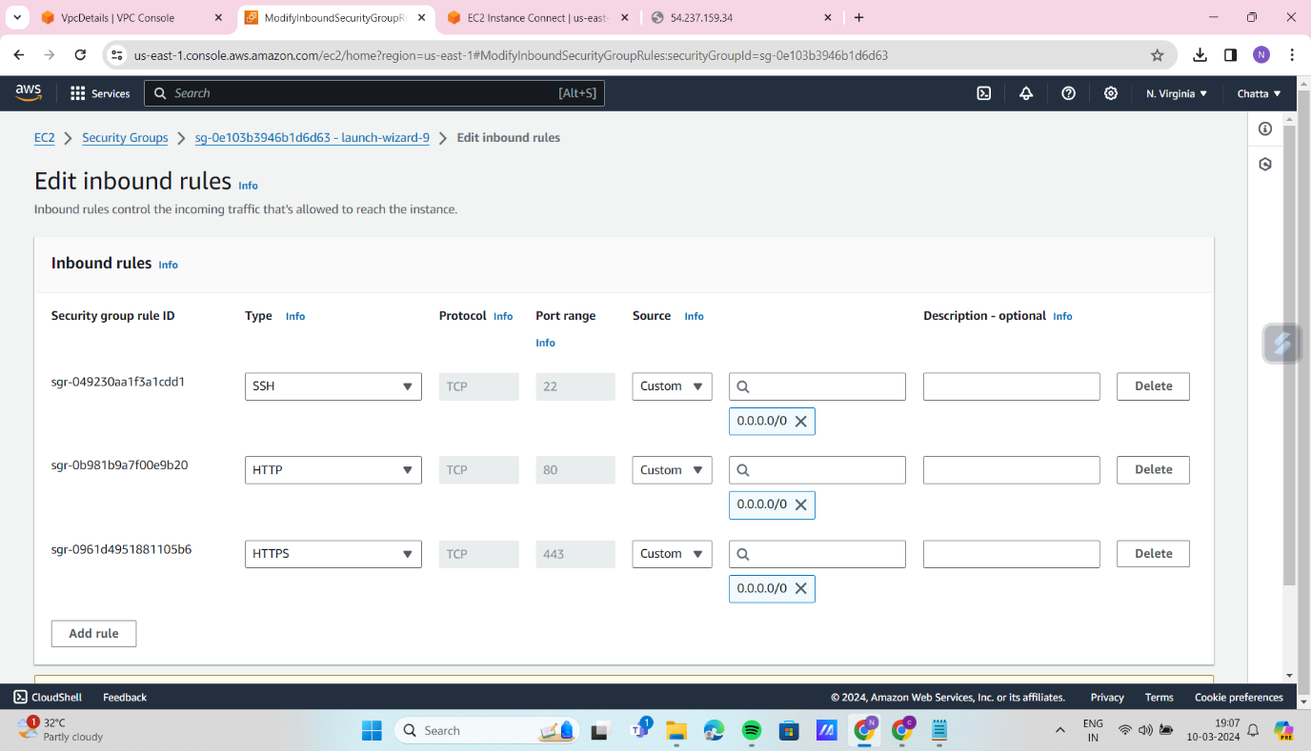

2.7 Go to ec2 and click on security groups and click on edit inbound rules and add new rule that is given below

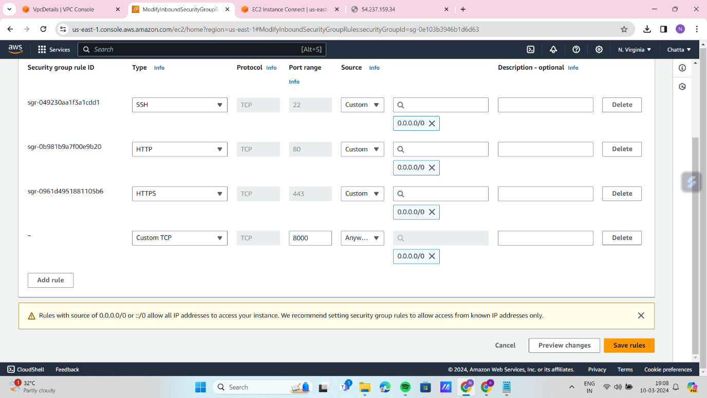

2.8 Go to vpc and navigate to Network Acl’s and click on edit inbound rules check all traffic allowed or not .(optional)

2.9 Go to new tab copy the Public Ip of your ec2 you will see the python application on port 8000.